Retail Profitability & Performance Analysis Dashboard

Dataset (Kaggle)
Dataset Name:
Walmart Store Sales Forecasting Dataset
Source:
Kaggle – Retail sales data containing weekly sales, store details, and economic factors.
https://www.kaggle.com/datasets/aslanahmedov/walmart-sales-forecast

Tables Used:
- train – weekly sales data
- features – economic & promotional factors
- stores – store metadata (type & size)
- test – not used (future prediction reference)
Time Period:
2010 – 2012 (weekly data)

Data Cleaning Steps (Power Query)
Performed using Power Query Editor:
Common Cleaning
- Corrected data types (Date, Decimal, Whole number)
- Removed errors & null values
- Trimmed and cleaned text columns
Features Table
- Replaced NULL values in MarkDown1–5 with 0
- Converted IsHoliday to TRUE/FALSE
- Ensured numeric columns are Decimal
Data Modeling Decision
- Merged features into train using:
  - Store + Date
- Removed standalone features table after merge
✔ Prevented relationship ambiguity
✔ Improved performance and clarity

Data Model
Data Model Structure:
stores (Dimension)
|
| 1 → *
|
train (Fact table with merged features)
Relationships
- stores[Store] → train[Store] (One-to-Many)
Why this model?
- Stores table has unique keys
- Sales table contains transactional data
- Features share same granularity as sales
✔ Clean star schema
✔ Interview-ready model

Measures (DAX)
Total Sales
Total Sales = SUM(train[Weekly_Sales])

Total Cost (assumed cost % for analysis)
Total Cost = [Total Sales] * 0.75

Profit
Profit = [Total Sales] - [Total Cost]

Profit Margin
Profit Margin = DIVIDE([Profit], [Total Sales])

Holiday Sales
Holiday Sales =CALCULATE(
[Total Sales],
train[IsHoliday] = TRUE()
)

Total Sales
Total Sales = SUM(train[Weekly_Sales])
Average Weekly Sales
Avg Weekly Sales = AVERAGE(train[Weekly_Sales])

Sales by Store
Sales by Store = CALCULATE(
[Total Sales],
ALLEXCEPT(train, train[Store])
)

Holiday Sales
Holiday Sales =CALCULATE(
[Total Sales],
features[IsHoliday] = TRUE()
)

Non-Holiday Sales
Non Holiday Sales =CALCULATE(
[Total Sales], features[IsHoliday] = FALSE() )

Sales YTD
Sales YTD =TOTALYTD(
[Total Sales],
train[Date]
)

Dashboards
Sales Overview
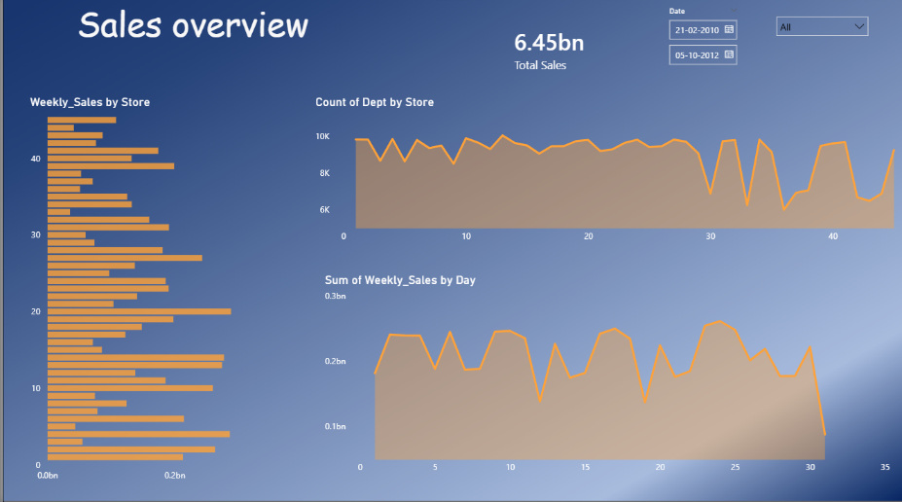

Profit Overview
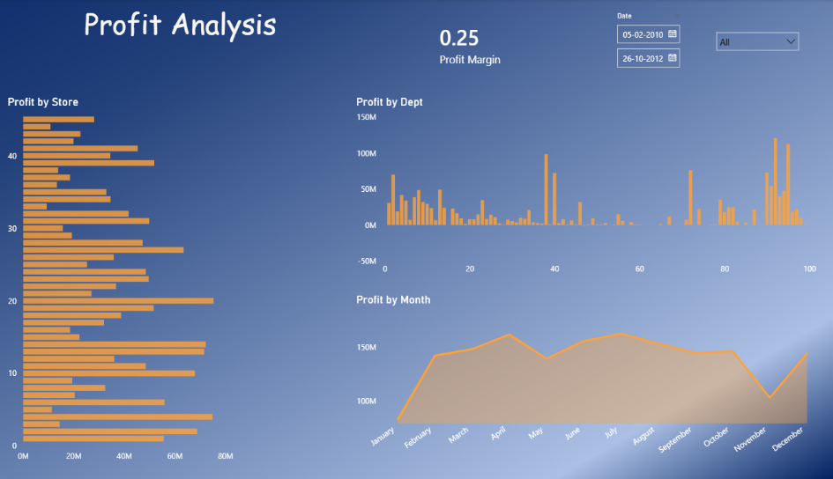

Store Performance
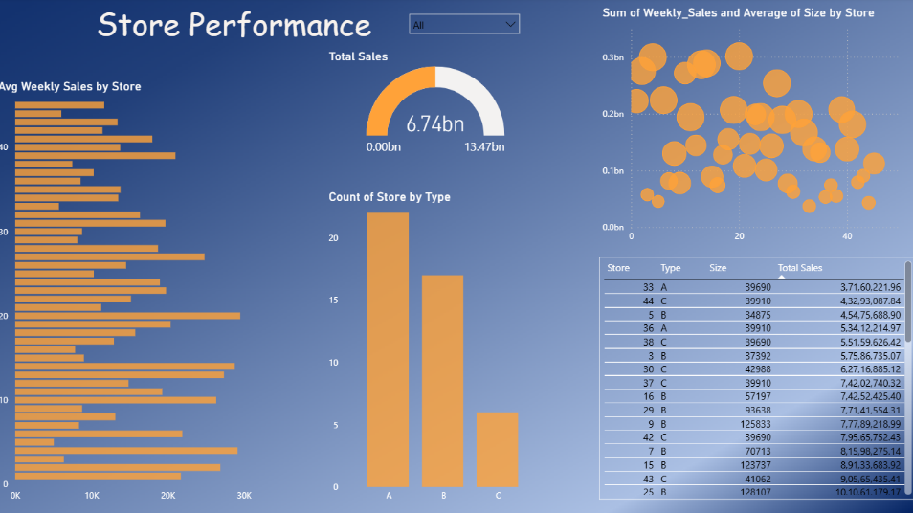

Impact Analysis
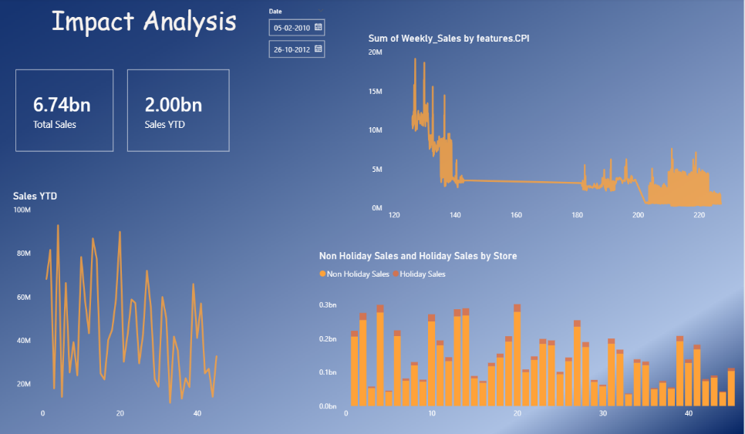
Business Insights
Key Insights Identified:
- Store Type A generates highest revenue
- Promotional weeks significantly increase sales
- Holiday weeks outperform normal weeks
- Large store size correlates with higher profitability
- High fuel price periods slightly reduce sales

Business Recommendations:
- Increase promotions during non-holiday periods
- Focus inventory planning for high-performing store types
- Optimize operations in low-performing stores

Tools & Skills Demonstrated
✔ Power BI
✔ Power Query (ETL)
✔ Data Modeling
✔ DAX (Measures & Calculations)
✔ Business Analysis
✔ Data Visualization

